

West Wales Regional Athletics Council

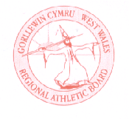
Minutes – West Wales Regional Athletics Council
Friday 7th February 2025
Microsoft Teams Meeting
__________________________________________________________________________________________
Present: Rob Campion Chairman
Nathan Jones Secretary
Les Cuthbert Treasurer
Andrew Jenkins Afan Nedd Tawe Schools Athletic Association
Lisa Campion Track & Field Committee Representative
Nigel Jones Officials Committee Representative (Endurance)
Owain Schiavone FMR Committee Representative
Jennifer Boyce Pembrokeshire Harriers
Helen Williams Llanelli AAC

_______________________________________________________________________________________

Apologies: Kevin Tobin, Gareth Harries, Aled Jones-Davies, Steve Hames
_______________________________________________________________________________________

Actions from Previous Meeting
Starter Kit - currently stored in Pembrokeshire ready for West Wales indoor championships.
_______________________________________________________________________________________

- Discussion

- West Wales indoor update and regional events – Cardiff and Day 1 Swansea
200m to 1500m events incorporated into the junior open at Cardiff. Better turnout for endurance races.
Jumps day success at Swansea in January with over 100 entries. Saturday 15th February is the Track/Shot, organization in place.

- UK Inter-Counties Cross Country Championships - March
West Wales teams finalised for the UK Inter Counties Cross Country Championships which are incorporated into the 5th and final round of the British Athletics Cross Challenge Series at Nottingham.
This year’s selection criteria:
- For the U20 and Senior teams, there will be no selection criteria, instead expressions of interest of representing West Wales emailed to the team manager.
- For the U13, U15 & U17 teams, the first six West Wales eligible athletes to finish at Newtown received automatic selection. U13 U15 & U17 athletes who finished outside of the top six places wishing to be considered for selection to fill the remaining 2 team places were required to email the team leader.

- Welsh Junior League 2025 – plans for the West Wales region
West Wales to continue with the same set up as in previous years. Running a full programme for U11, U13 and U15 age groups. Request for Brecon AC to join was accepted. Swansea confirmed as 7th June. Possible other two dates: 18th/19th May at Brecon; 2nd/3rd August at Carmarthen (need to confirm).

- West Wales Outdoor Championships – May 10th – U11 Run, Jump, Throw
West Wales Outdoor Championships at Swansea in May, running on the same day as the other regions. Idea to include an under 11 run, jump, throw element (75m, long jump, shot) into the event as limited opportunities elsewhere for this age group.

- Inter-Regional events – Caerphilly / Track and Field July
West Wales to host the 2025 edition of the Inter Regional Championships in the region. 12th July booked Carmarthen, licence to be applied. Timetable is fixed with the third year in operation - half event timetable. Caerphilly 10K is the Welsh inter-regional 10K championships, more information to be promoted soon. In addition and confirmation, 10K regional championships at the St Clears 10K in August.

- Gerry Batty Award
West Wales Regional Athletics Council Gerry Batty Memorial U17/U20 Junior Athlete of the Year Award, over the period 1st October 2023 to 1st October 2024 inclusive. Four athletes shortlisted, Gracie Griffiths recipient this year based on her achievement becoming British Senior champion in the race walk. Despite being awarded over a number of years, officers agreed that the award will be removed, some of the reasons include the criteria has changed several times and that it is becoming increasingly difficult to decide between various performances.

__________________________________________________________________________________________
- Information – Reports

- General Council
Nothing to update in the recent meeting.

- Track and Field Committees
New Age Group proposals, meeting set with James Williams. Reminder to clubs that registration closing times for championships are there to be followed.

- Officials Secretary
Welsh Athletics officials meeting held recently. It was raised about mileage rates for Welsh events, money is tight with WA.

Another interesting point raised is the level of meetings needs only be L1, a lot are applied for as L2.
L2 meetings should only be for champs and means you need a higher number of upper level officials and more technology. Any of our league meetings or regionals can be L1 only.

- Officials Committee
Course for Race Directors held in January, follow up course at Carmarthen on 29th March following change to road relays date.

- Road Running/Cross Country Committee
Welsh Athletics Road Relay Championships for seniors and master will be on 22nd March at Pembrey (Changed from 29th as another booking).
There will be two races:
Senior Men and Women
Veteran Men and Women
Veterans can compete in both races if they wish. Junior relays to take place in September, date and venue to be confirmed.

Welsh Schools and Inter Schools XC
Welsh Schools have issued a consultation with various options:
Event to remain combined, Schools and Inter Regional to be held separately, Schools replaced with a relay and Inter Regional to be stand-along (not a relay)

- FMR Committee
As an alternative to the Red Kite Challenge, Nant Yr Arian Silver Trail Half Marathon on Saturday 22nd March is the Welsh short trail championship race (Road Relay clash now happens here). British & Irish Mountain Running Championships: suggested Devil’s Bridge previously however now likely to be in North Wales in September.

- Welfare Officer
Nothing to update.
_______________________________________________________________________________________
- Financial Report

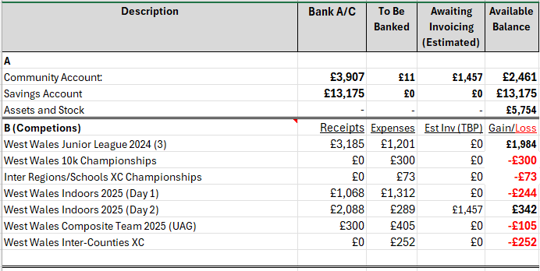
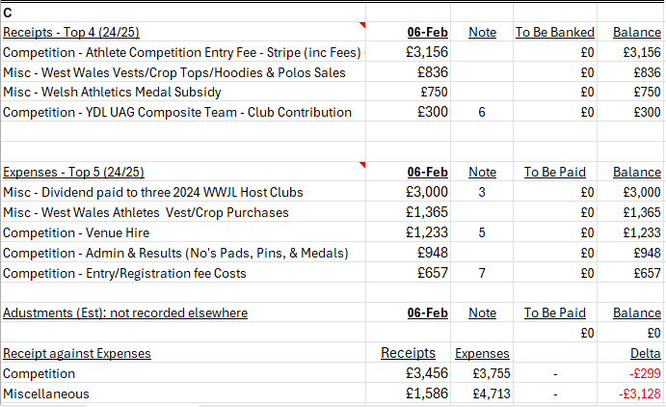
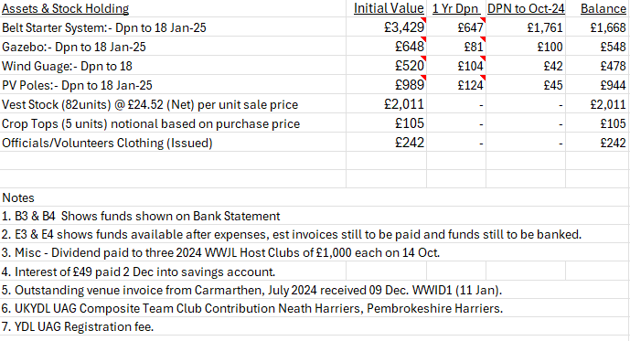

- Purchase EDM from NUEF for £7k. Subject to business case being approved by W2RAC committee – Preference is to continue to hire from WA for cheaper as it’s unlikely to be used regularly. There is also the additional charging costs for collaboration / servicing each year.
- Travel costs for Athletes (+1) and Officials attending Inter-Counties in Nottingham to be partially met. Form to be set up that those who wishes to receive small contribution can complete.

- AOB

- Photofinish course in West Wales at Swansea on Saturday 8th March, the region will pay for up to three individuals to attend. The individual should either live in the West Wales (WW) catchment area or belong to a WW Club. Reimbursement of course costs will be made following attendance at two WW hosted meetings. Travel Costs to Swansea.
- Pembrokeshire Harriers have set up a committee meeting to discuss the future of the junior section moving forward due to the number of qualified coaches and volunteers currently in place.

- Date of Next Meeting Friday 11th April at 6:30pm – Canolfan Gwili, Hendy (in person/online)

